An investigation on crystal features

Oliver BACG ¹*, Harry BACG ¹, Emma BACG ², Leonardo BACG ³

¹ Department, Institution, country
² Department, Institution, country
³ Department, Institution, country
*e-mail address of lead presenter

Crystal features have been investigated / measured / modelled / applied ... Figure 1 shows….

[main content of second paragraph]

Reference
1. Article title1, all authors, journal, year, pages
2. Article title2, all authors, journal, year, pages

[All content: Arial font of 12 point, copy and paste all the above paragraphs and references into Content, using special character keyboard if necessary. You do not need to copy and paste title, authors and affiliations into Content,]
]

[No more than three paragraphs and no more than two figures / tables.]

[No more than 450 words including references.]

[All figures and tables below with figure captions or table titles, without other text, upload as a single PDF file into Supporting Information. You can choose to add the abstract title in the supporting information]

An investigation on crystal features

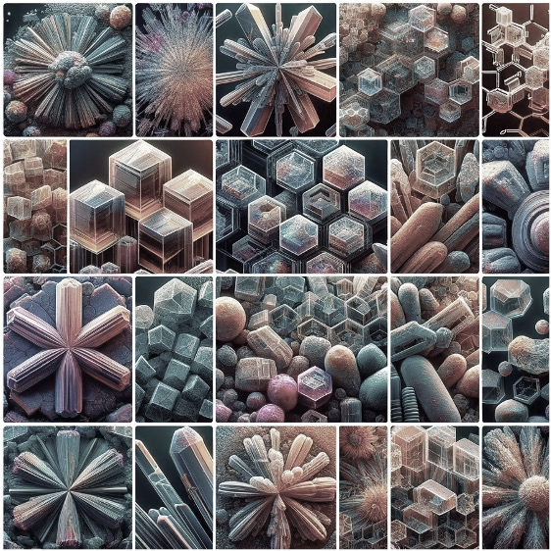
Figure 1 Crystals with different features

